AIPP LAB 15

Name: SYEDA FARHATH UMAMA
Hall Ticket No.: 2503B05143

Task Description #1 – Remove Repetition
Task: Provide AI with the following redundant code and ask it to refactor

Expected Output
- Refactored version with dictionary-based dispatch or separate functions.
- Cleaner and modular design.

CODE:
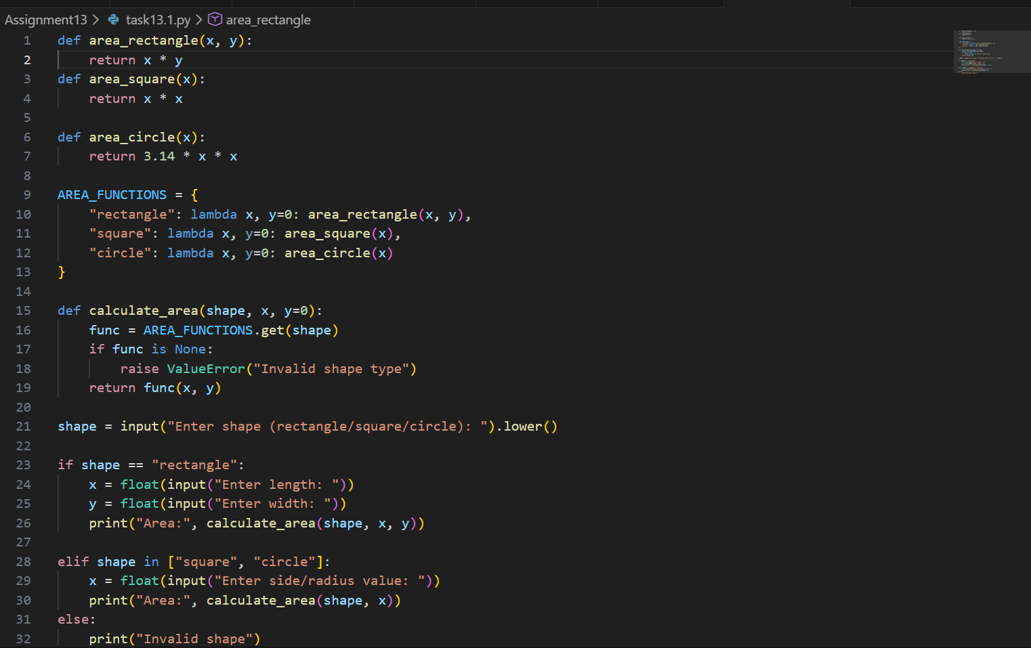

OUTPUT:
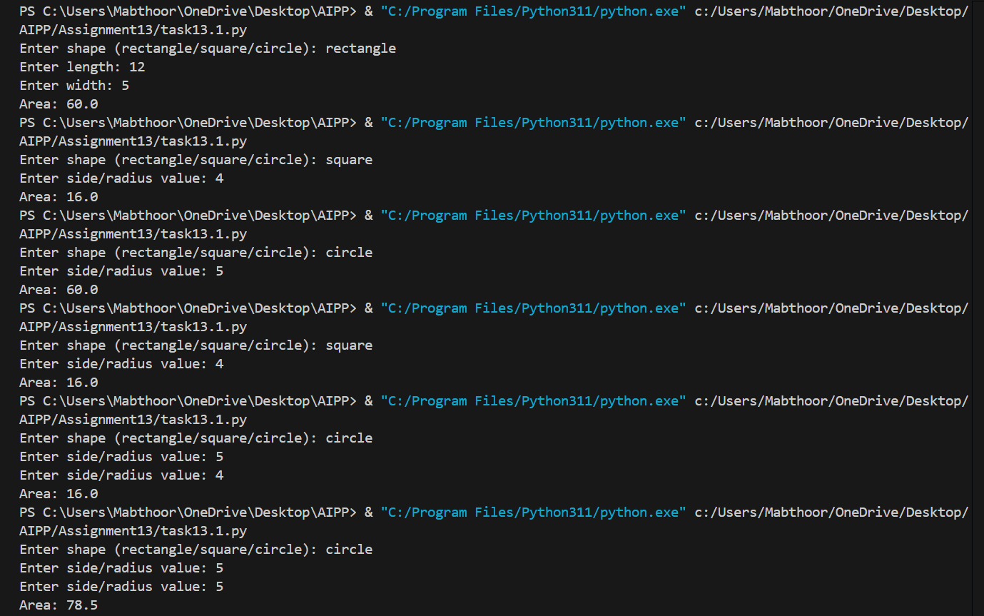

Task Description #2 – Error Handling in Legacy Code
Task: Legacy function without proper error handling

Expected Output:
AI refactors with with open() and try-except:

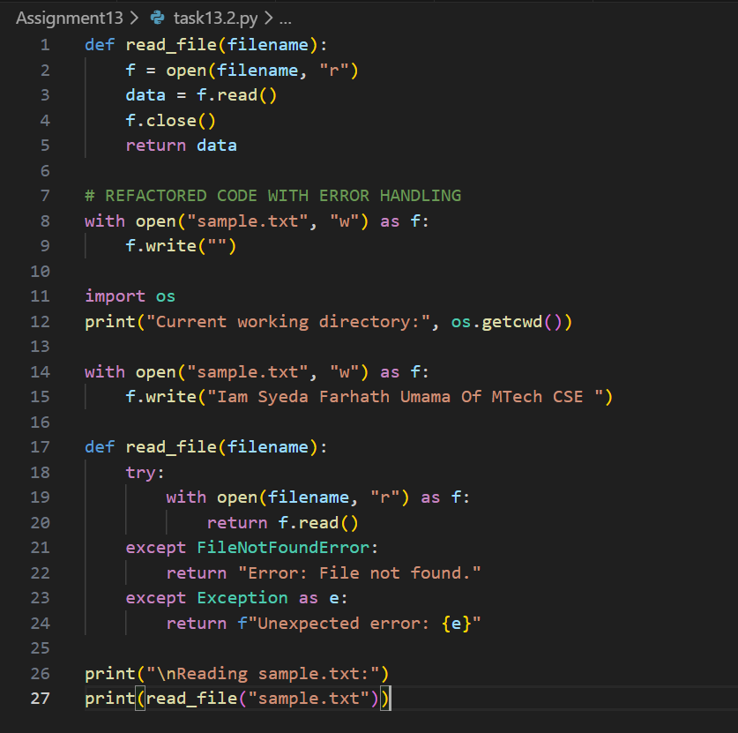

OUTPUT:
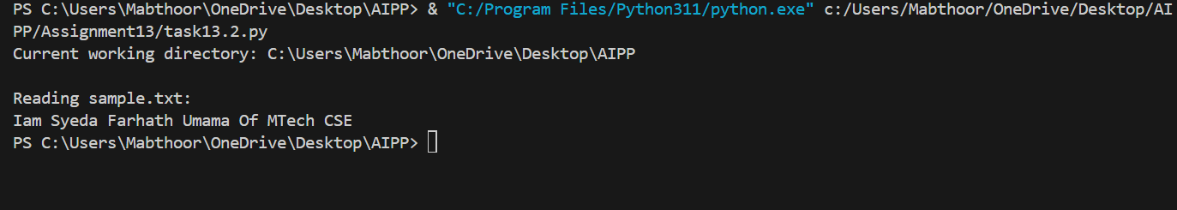

Task Description #3 – Complex Refactoring
Task: Provide this legacy class to AI for readability and modularity improvements:
Expected Output:
- AI improves naming (name, age, marks).
- Adds docstrings.
- Improves print readability.
- Possibly uses sum(self.marks) if marks stored in a list.
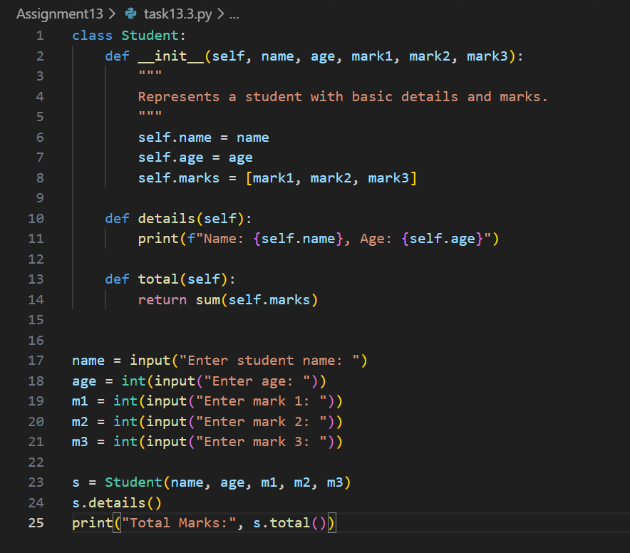
OUTPUT:

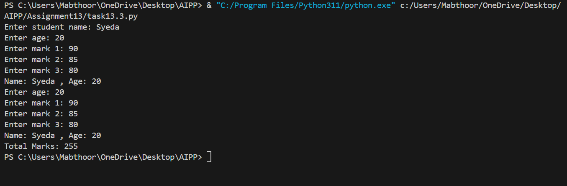

Task Description #4 – Inefficient Loop Refactoring
Task: Refactor this inefficient loop with AI help

Expected Output: AI suggested a list comprehension

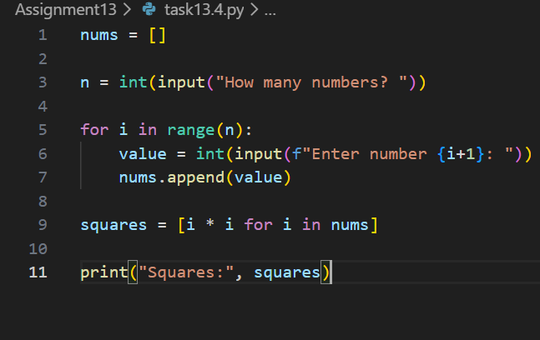
OUTPUT:

